

Created for Thoughtful Engagement

February 2021 Blog 10

By Holly J. Bean, PhD, LCPC, CRC, CTRS

Grit, Resilience, and COVID 19

The pandemic has provided many opportunities for growth, particularly in rethinking living alone. Thankfully, I live in a community and we do take care of each other, but after losing my dog and my cat this past summer, I find that for the first time in my life I am actually living alone.

Like most women, I’ve spent my life taking care of others. Husband, children, PTO meetings, Church, fund raisers, and on and on were the mainstays in my daily schedule. In my newest incarnation (trust me there have been many) I have been given a gift. Truthfully, I didn’t see it as a gift at first. In fact, I felt isolated and lost. I am at my best when taking care of others. It didn’t enter my realm of consciousness that taking care of myself should be in the mix. I felt strongest when helping others get through any type of challenge or catastrophe.

As a psychotherapist a majority of my current clients are young adults who are having difficulty navigating this very trying time. For the first time in their young lives they are facing a major challenge that threatens their sense of self. Searching for answers to help this population, I remembered a lovely older woman, a patient at the hospital I worked in. She was sitting on her bed, dressed beautifully, smiling at me. Her prognosis was not good, she was not going home, but to a facility for the remainder of her life, yet she was smiling, pleasant, and answered my routine questions happily. I had to ask her how she was able to maintain such a positive attitude. Her response was simple, “I have learned to adjust.”

This simple, but profound statement is something that I have worked to employ in my own life. Adjust to the situation at hand. Those that are able to adjust to adversity with the ability to understand that this too shall pass seem to have what might be called grit. Merriam Webster Dictionary defines grit as “mental toughness and courage”. Angela Duckworth from the University of Pennsylvania has written much on grit and notes that it is the “perseverance and passion for long term goals” (Duckworth et. el, 2007). Others offer the definition of grit as the “the tendency to pursue long-term goals with sustained zeal and hard work” (Von Culin et al., 2014). I didn’t feel that grit was the only characteristic this lovely, dignified, older woman had. There was something in addition to grit. That something was resilience. Continuing with Merriam Webster, the definition of resilience is “an ability to recover from or easily adjust to misfortune or change”. The word resilience comes from the Latin verb resilere, which means to “spring back, to rebound” (Merriam Webster). Research has shown that resiliency is closely related to optimism. Martin Seligman, a professor at the University of Pennsylvania, also known as the Father of Positive Psychology, notes that people who are optimistic see setbacks and challenges as “temporary, local, and changeable” (Seligman, 2011)

In my quest to understand grit and resilience, I learned of another key ingredient in the process of adjusting. Carol Dweck, a psychology professor at Stanford University, is well known for her work on the mindset psychological trait. In the past, mindset (intelligence) was thought of as “fixed” or static, non-moving. Carol Dweck’s theory supports that growth mindset intelligence can be developed and is fluid, not fixed (2006).

The two mindsets that Dweck describe are depicted below:

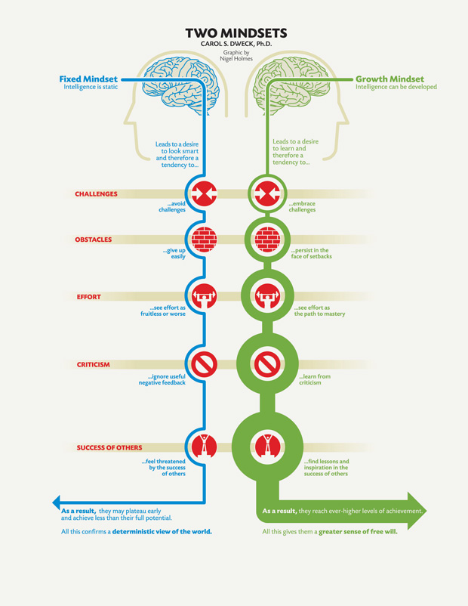

It is with grit, resilience, and a growth mindset, that I have come to love living alone. It is challenging and rewarding. I see each day as an opportunity to adjust. And it is my sincerest wish that I can share, with the same quiet dignity of my lovely older patient, the possibilities that come with adjusting.

References

Duckworth, A. L., Peterson, C., Matthews, M. D., & Kelly, D. R. (2007). Grit: perseverance and passion for long- term goals. Journal of personality and social psychology, 92(6), 1087.

Dweck, C. (2006). Mindset: The new psychology of success. New York, NY: Random House.

Seligman, M. E. (2011). Building resilience. Harvard Business Review, 89(4), 100-6.

