
Created for Thoughtful Engagement
September 2021 Blog 17
By Holly J. Bean, PhD, LCPC, CTRS

Fall

Most people have a favorite season. There are those who love the outdoor busy-ness that summer brings with so much fun to be had. Although I take advantage of all the opportunities that summer offers, my favorite season is fall. It brings an instinctual component where our internal time table tells us to prepare for winter, yet also gives us the gift of a beautiful segue; pleasant weather, and depending on where you live – fall foliage. Here in New England, it is the time of year where one can continue kayaking while being surrounded by a glorious explosion of colors. The trees that blended into each other’s greenness all summer, now show their individuality and color preference. Fall tells us it’s time to put away the summer clothing and toys or tools. The garden is to be harvested and put to rest for its winter nap. It feels that there is a collective deep breath as we prepare for what’s next. We tend to slow down. Lawn mowers have become quieter, replaced with the sound of rakes and the softly falling leaves.

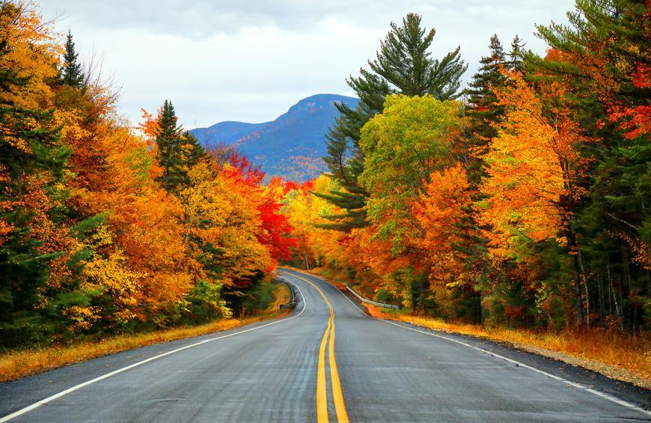

I have a friend who’s kitchen was turned into a canning industry during the fall. Tomatoes, corn, green beans all preserved for the long winter months. My mother used to make sauerkraut in the fall, put up for future use. Summer clothing is packed up and stored away, waiting patiently for their turn to see daylight again. Sweaters and lightweight coats are included for daily wear, as are socks. Shoes and sneakers replace sandals. My winter coat hangs ready in the closet, knowing it is next in line.

Apples and cider usher in the season, as do hearty meals of soups and stews. Pumpkins are placed by the doorstep, some carved and others left to their own splendor.

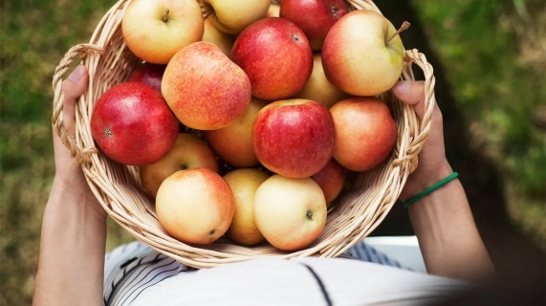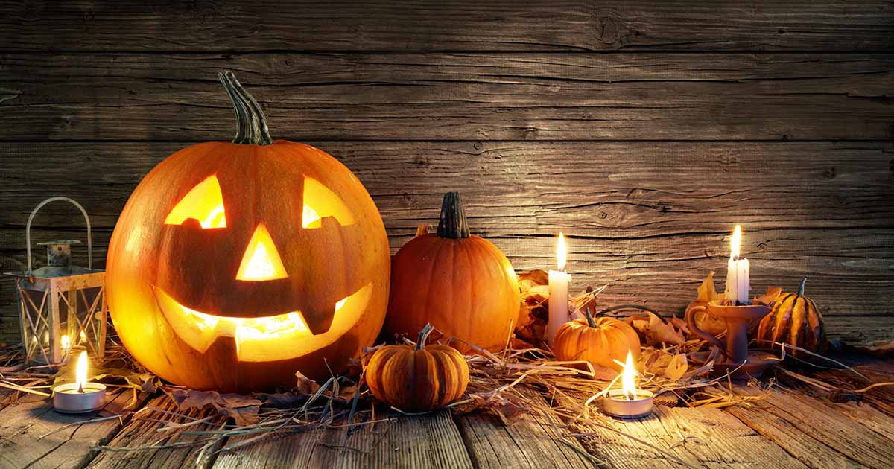
Bonfires now have a second mission, other than providing the means to make s’mores, it now acts as a heat source on a chilly fall evening.

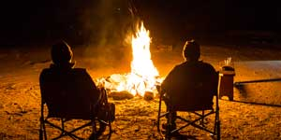

Some find the fall a harbinger of the cold to come. And in all honesty, it is. Yet, the cold white, winter months bring its own wonder, beauty and memories.

In the meantime, we can enjoy the beauty that fall shares. And the pace that it asks us to take, reminding us that it is time to slow down.

