

Created for Thoughtful Engagement
November/December 2021 Blog 18
By Holly J. Bean, PhD, LCPC, CTRS

The Holidays and Emotional Wellbeing

November ushered in the start of the holiday season. Not only has the holiday season begun, but also for some of us in the northern hemisphere something called daylight savings has taken over and feels like our daylight hours have been sabotaged. Our days are shorter and evening darkness appears to be eternal.

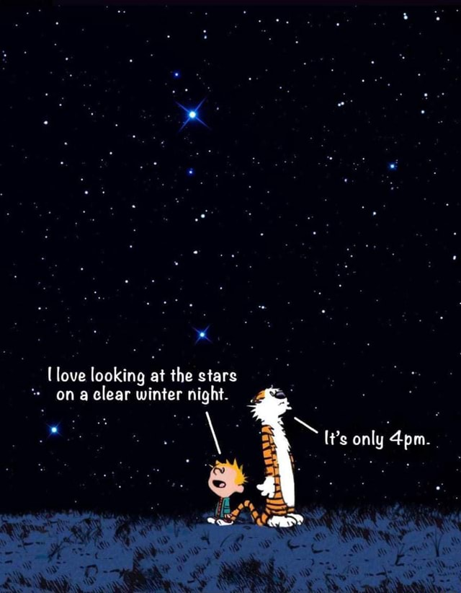

Regardless of one’s religious or secular affiliations, we are inundated with decorations, images, and marketing techniques geared toward pulling us into the festivities. Tis the season to be jolly, deck the halls with boughs of holly, Rudolf the red-nosed reindeer, beautiful lighting, and something else.


For some of us this something else can take the form of no motivation, sadness, or even depression. We might even feel that we are in a sort of a funk. Well-meaning people may ask us, “Are you done with holiday shopping” in an excited tone, while we inwardly lament that we haven’t even started yet.

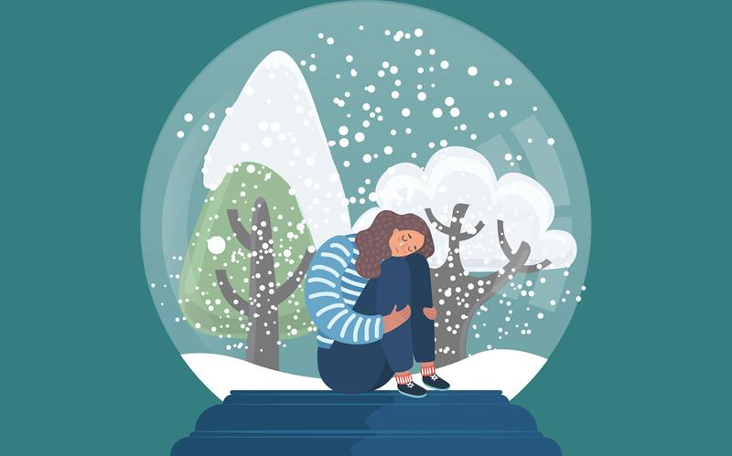

During this time we might feel like the toys on the imaginary island of Misfit Toys, as noted in the Rudolf TV program. The song “why am I such a misfit” may dance in our heads, taking the place of the sugar plum fairies.

Compassion, empathy and patience all can help during this time period. Compassion starts with yourself and then can spread to others. First and foremost, it is not necessary to compare ourselves to others during this time – we do not all have to enjoy the holidays, we can take care of our needs in the best way possible. That might mean understanding that during this time period we may need to support ourselves, to go within to seek solace. This is very different than completely withdrawing. In reality we are all social creatures and need to live interdependent lives. When the seasons change and daylight gives way to longer evening hours, we naturally, instinctively want to hibernate. As a mental health counselor, I see more clients during this time period than at others. Seeking help with processing our emotions, our needs, and how to move forward in a healthy direction is compassionate self-care. In addition, the pandemic has also created its own requirement for withdrawal, which inevitably produces additional anxiety and other emotions.

A reduction in daylight can cause SAD, Seasonal Affect Disorder. Many of us suffer from this disorder, but may not have been diagnosed. Yet, we know something is askew. The Mayo Clinic notes, “Seasonal affective disorder occurs in climates where there is less sunlight at certain times of the year. Symptoms include fatigue, depression, hopelessness, and social withdrawal. Treatment includes light therapy (phototherapy), talk therapy, and medications”. The good news is that there is assistance available.

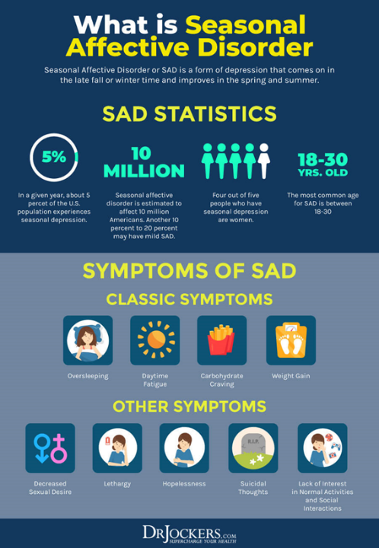

Help is available. See your doctor, talk to a counselor, and share your feelings with loved ones. You are worth it. And this too will pass by utilizing healthy options.
